Apache Based Centralized Yum Repository

**At Server Side: -**

1. Mount the Redhat enterprise linux dvd to /mnt directory-

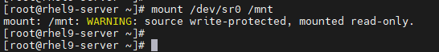

2. Verify it using df -Th command-

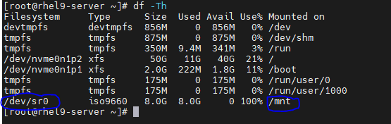

3. Move existing repository from /etc/yum.repos.d to /tmp-



4. Create directory /local_repo to copy mounted dvd contents-



5. Create local repository file in /etc/yum.repos.d with extension .repo-



6. Copy the dvd content from /mnt to /local_repo-



7. Enter repository details in local repository file in /etc/yum.repos.d/local.repo-



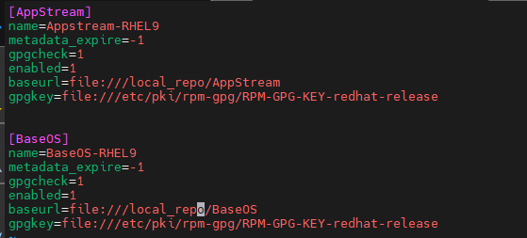

8. Run yum repolist command to check whether it is working or not-



9. Install few packages to creating, configuring & managing local repositories-



10. Create repository using createrepo command-



This will take 2-3 min to complete.

11. Cleanup temporary repository files-



12. Check repodata content (Created during step 10), as it will be used to setup apache based yum server-

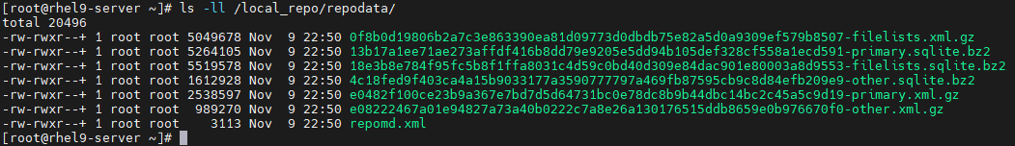

13. Disable Redhat subscription warning-



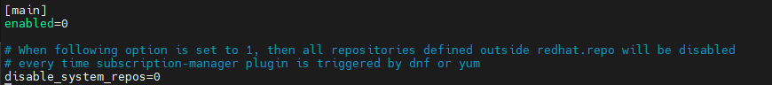

Make enabled=0

14. Install http packages-



15. Start & enable httpd service-



16. Check httpd service status-

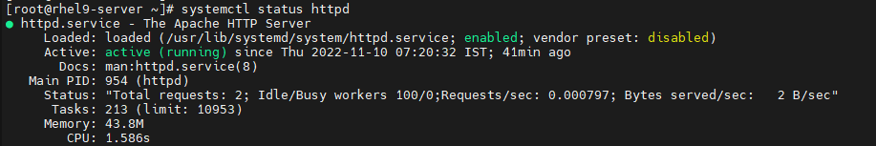

17. Add http & https in firewall, reload & verify it-

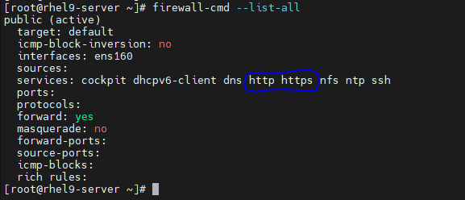

18. Verify apache is up & running from web browser using server’s IP address.

19. To make changes in default configuration file-



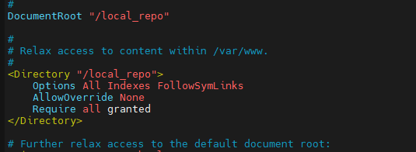

20. Restart httpd service-

21. Remove welcome page from the mentioned location-



Now test the httpd as shown-



22. Change permission to give rwx permission to apache user using ACL-



23. Check if SELinux is enforcing-



24. Check default semanage policy on /var/www/html-

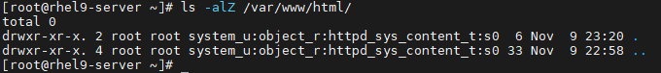

25. We have to set same policy on /local_repo directory & on its subdirectories, files-



26. Verify it as shown-

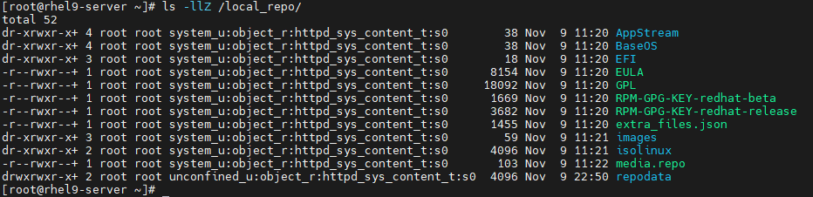

27. Verify whether packages are visible over http-

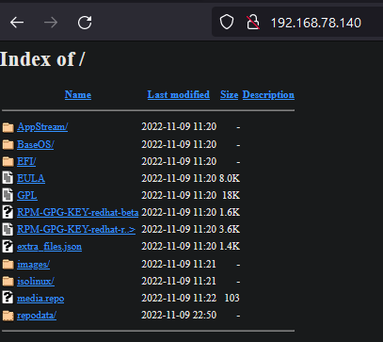

28. To verify repository at server side, install any package, ex- vsftpd

**At Client Side: -**

**Method 1 (Configure Manually):**

1. To configure yum at client, create a repo file & add content to pint to apache yum server as shown-



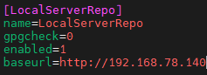

2. Verify configuration-



3. Try with installing a package using yum install.

**Method 2 (Configure Automatically)**

1. Use config manager to setup it-



2. Verify it-

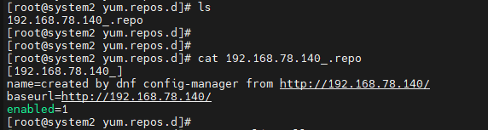

This is it!!!!!